**Lab 5: Configure Single Area OSPFv2**

Course Code - Course Name: - COMP4039 – Network Foundations

Program: T433 - Cybersecurity

Section: A

Term: - Winter 2024

Group Number: 06

Student Names - ID:

* Prabhjot Singh Sains – 101495218
* Rahul Patel - 101378458
* Jai Deep Rawat - 101503760
* M. Salmaan Mustafa Shah – 10151007

Lab Report by - Prabhjot Singh Sains

**Topology**

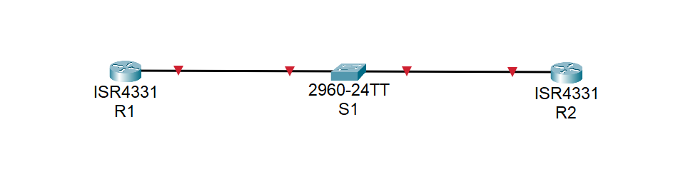

Fig. 1 - Topology

**Addressing table**

|  |  |  |  |
| --- | --- | --- | --- |
| **Device** | **Interface** | **IP address** | **Subnet Mask** |
| **R1** | G0/0/1 | 10.53.0.1 | 255.255.255.0 |
| Loopback1 (Lo1) | 172.16.1.1 | 255.255.255.0 |
| **R2** | G0/0/1 | 10.53.0.2 | 255.255.255.0 |
| Loopback1 (Lo1) | 192.168.1.1 | 255.255.255.0 |

**Part A: Set up the topology and initialize the devices:**

1. Interlink all the components shown in the topology diagram and turn on your devices.
2. Connect the rollover console cable to the RJ-45 console port of the Router R1 and R2 and start any available emulation program such as (Tera Term, putty, or Hyper Terminal)
   * For S1 you need to establish a console connection just to initialize it as shown in step 3.
3. Initialize and reload the router and switch to clear any existing configuration using the following commands:

Router> enable

Router# erase startup-config

Router# reload

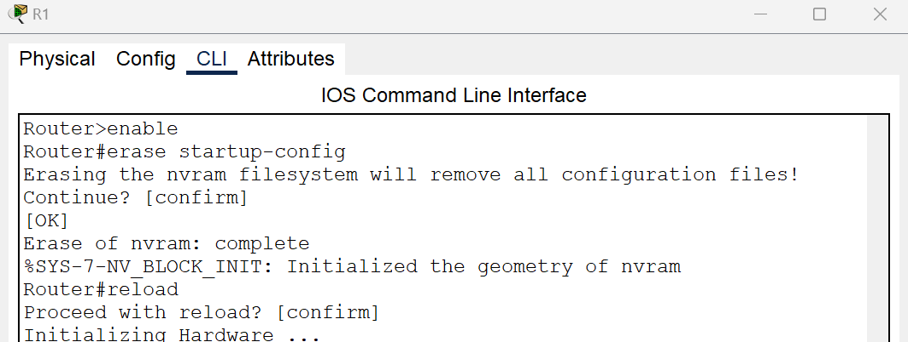

Fig. 2 – R1

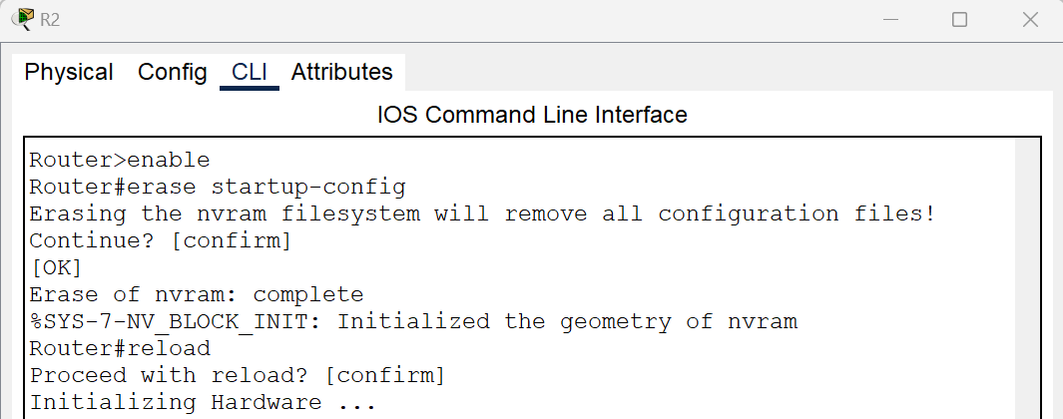

Fig. 3 – R2

Switch> enable

Switch# delete vlan.dat

Switch# erase startup-config

Switch# reload

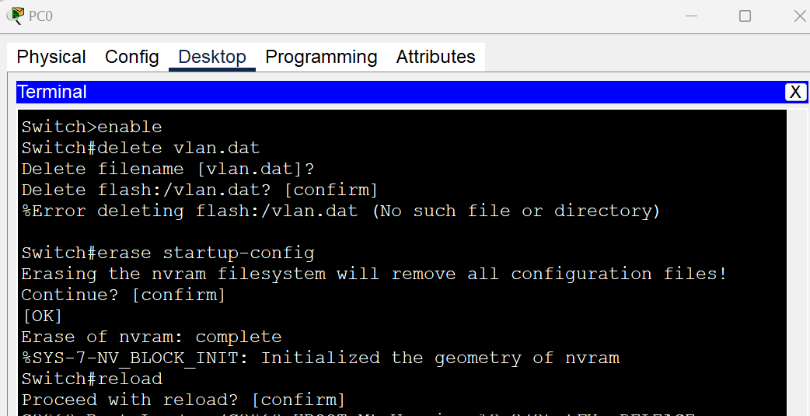

Fig. 4 – S1

**Part B: Configure basic configuration on R1 & R2 refer to Lab 4:**

1. Configure static IP address information on the PCs as shown in the topology diagram.
2. Configure and Verify Basic Settings for Router
   1. Enter privileged EXEC mode and then configuration mode.

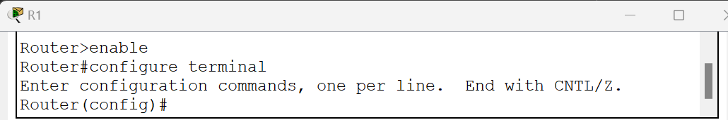

Fig. 5 – R1

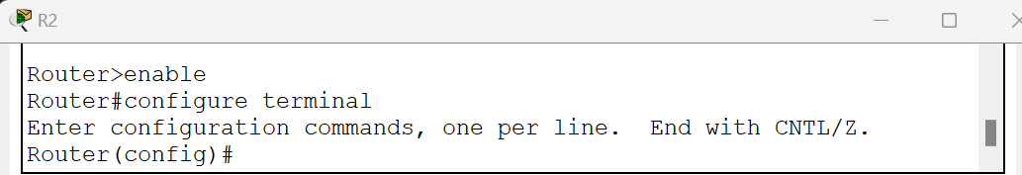

Fig. 6 – R2

* 1. Use the hostname command to change the router name to R.

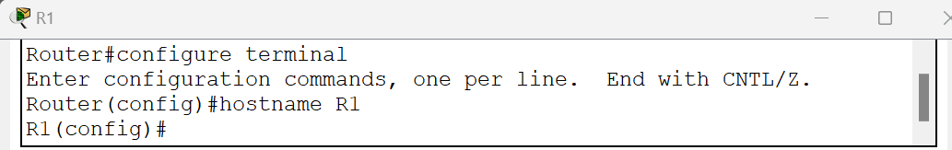

Fig. 7 – R1

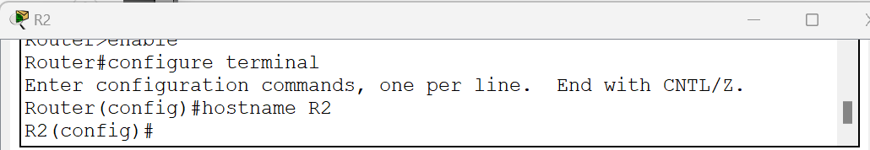

Fig. 8 – R2

* 1. Prevent unwanted DNS lookups.

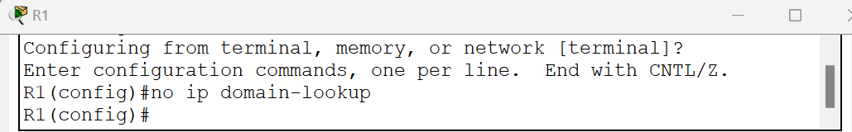

Fig. 9 – R1

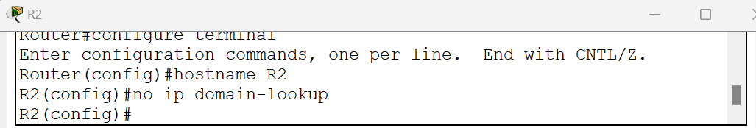

Fig. 10 – R2

* 1. Enter local passwords: To prevent unauthorized access to the router, passwords must be configured.

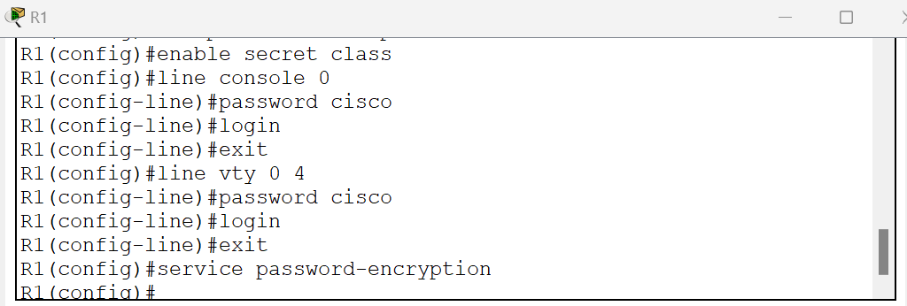

Fig. 11 – R1

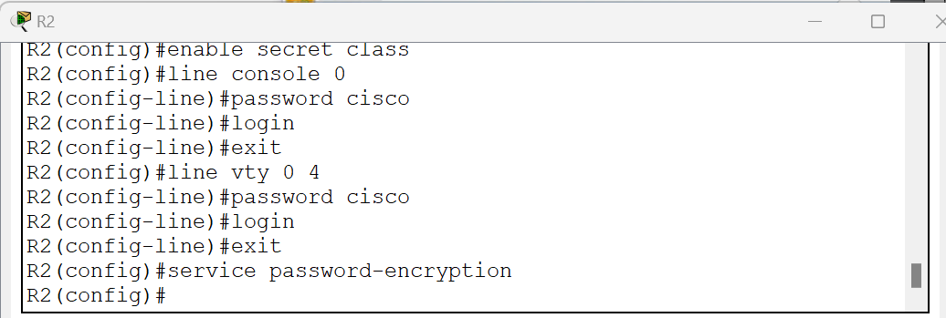

Fig. 12 – R2

* 1. Enter a login MOTD banner.

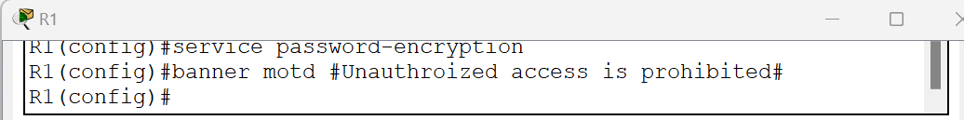

Fig. 13 – R1

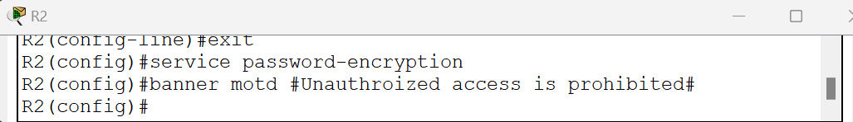

Fig. 14 – R2

* 1. Configure an IP address and interface description. Activate both interfaces on the router on both R1 and R2, refer to addressing table above.
     1. Note: to create a loopback interface use the command: interface loopback <int >

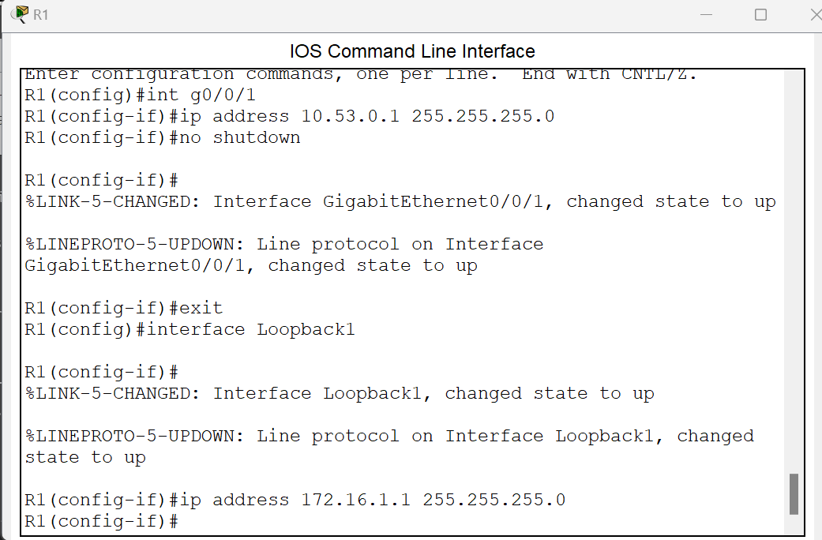

Fig. 15 – R1

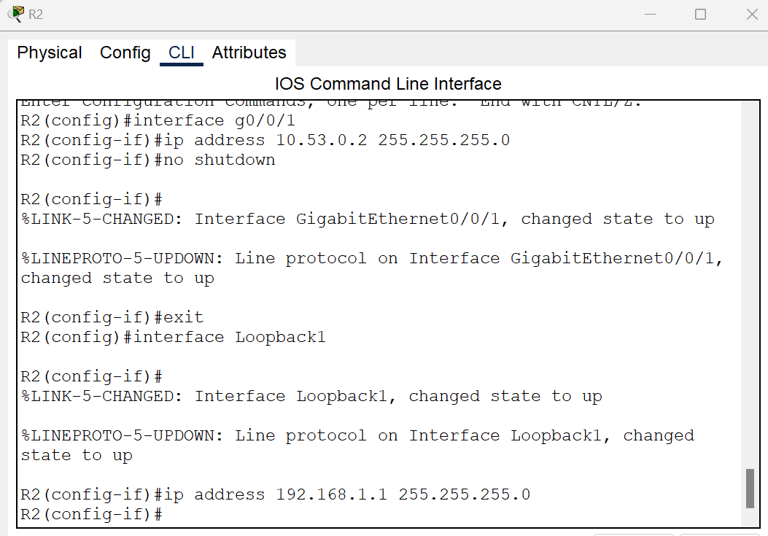

Fig. 16 – R2

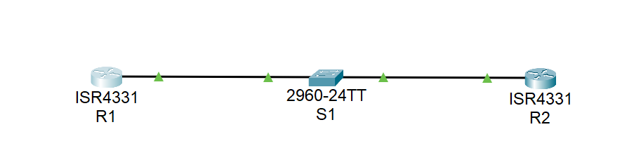

Fig. 17– Topology

* 1. Use the show command to verify your configurations.

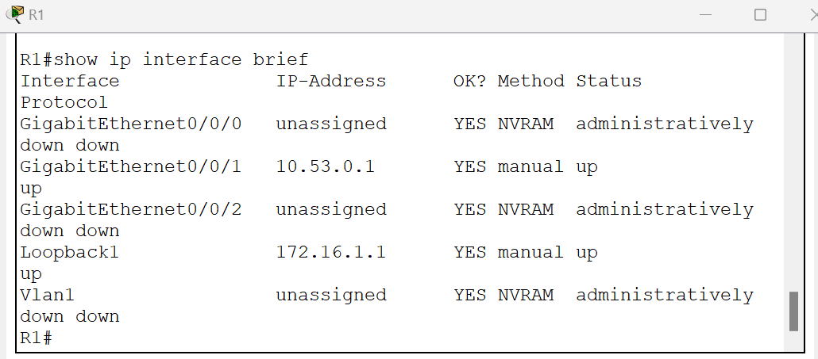

Fig. 18 – R1

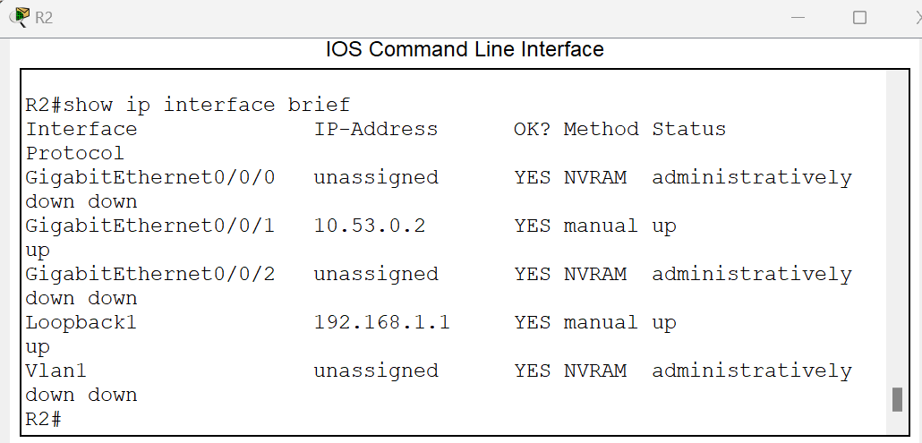

Fig. 19 – R2

* 1. Save the configuration.

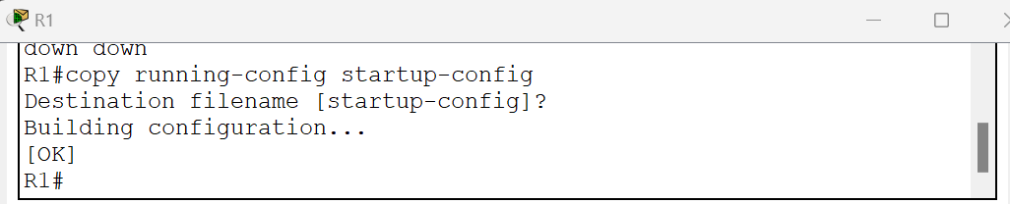

Fig. 20 – R1

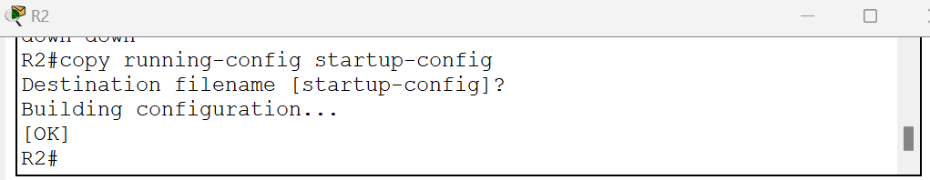

Fig. 21 – R2

**Part C: Configure and verify Single area OSPFv2 for basic operation:**

1. Enter OSPF router configuration mode using process ID 56.

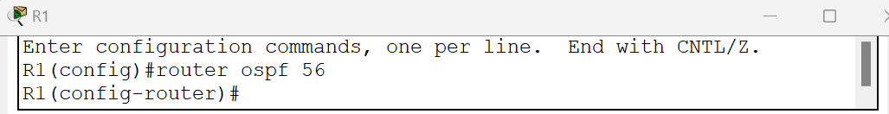

Fig. 22 – R1

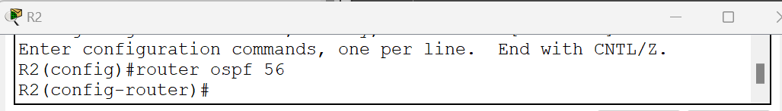

Fig. 23 – R2

1. Configure a static router ID for each router (1.1.1.1 for R1, 2.2.2.2 for R2).

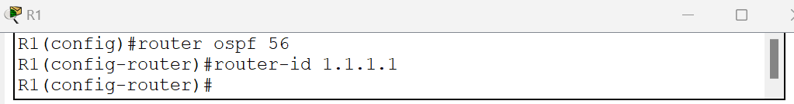

Fig. 24 – R1

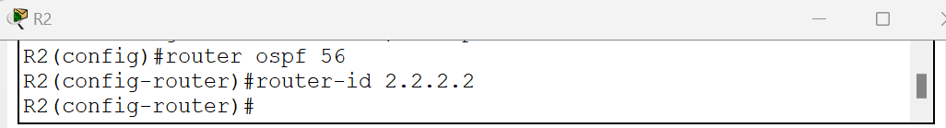

Fig. 25 – R2

1. Configure a network statement between R1 and R2 placing it in area 0.

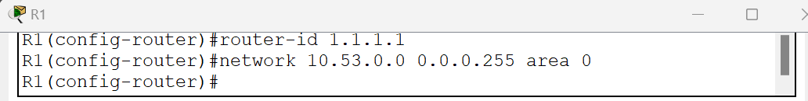

Fig. 26 – R1

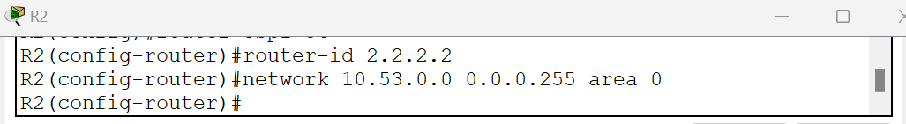

Fig. 27 – R2

1. Verify that OSPFv2 is operational between the routers. Issue the command to verify that R1 and R2 have formed an adjacency.

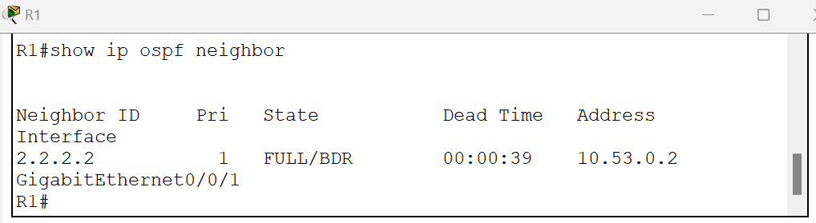

Fig. 28 – R1

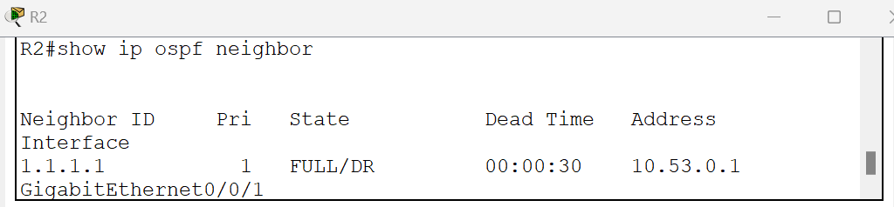

Fig. 29 – R2

**Ques.** Which router is identified as the DR? Which is the BDR? What were the selection criteria?

**Ans.** DR (Designated Router) is R1 and BDR (backup designated router) is R2.

The Priority field indicates the priority of the neighbor router. The router with the highest priority becomes the Designated Router (DR). If priorities are the same, the router with the highest router ID becomes the DR. By default, priorities are set to 1. R1 (Router ID: 1.1.1.1) has a higher router ID than R2 (Router ID: 2.2.2.2). Therefore, R1 will be the DR, and R2 will be BDR.

1. Attempt to ping the R2 G0/0/1 interface address from R1 and try to ping the R2 G0/0/1 interface address from R1. Were the ping attempts successful?

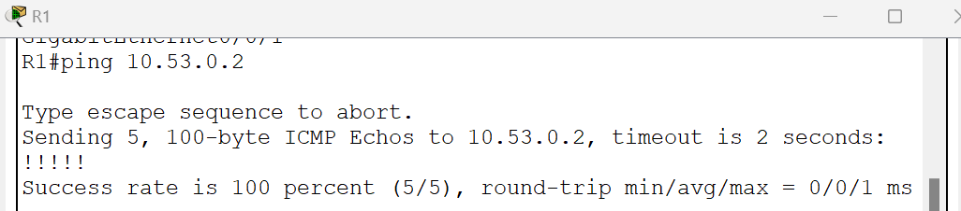

Fig. 30 – R1

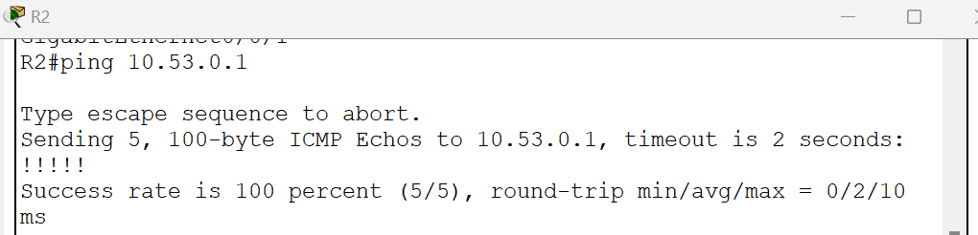

Fig. 31 – R2

The ping attempts are successful for the G0/0/1 interface address from both R1 and R2.

1. Attempt to ping the R2 Loopback 1 interface address from R1 and try to ping the R1 Loopback 1 interface address from R2. Were the ping attempts successful?

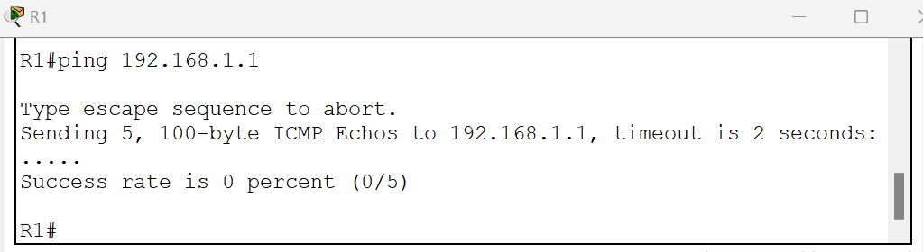

Fig. 32 – R1

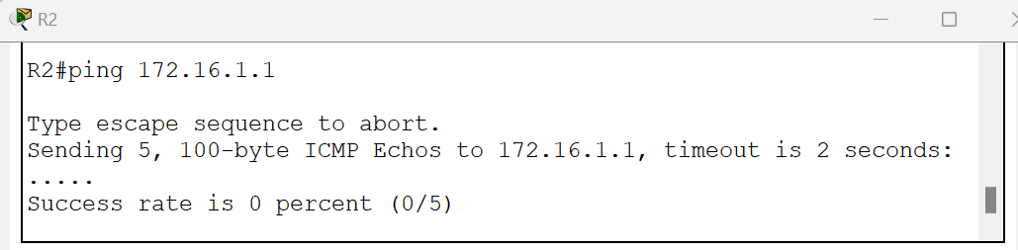

Fig. 33 – R2

The ping attempts are successful for the Loopback 1 interface address from both R1 and R2.

1. On R2 & R2, add the configuration necessary to advertise the Loopback 1 network into OSPF area 0.

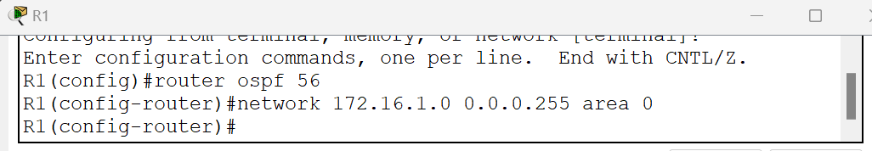

Fig. 34 – R1

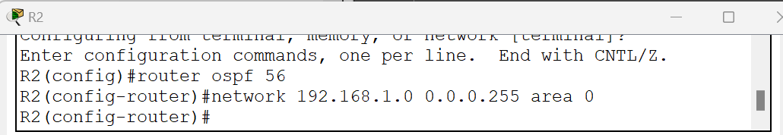

Fig. 35 – R2

1. On R1 & R2, issue the show ip route ospf command to verify that the R2 & R2 Loopback1 networks are present in the routing table.

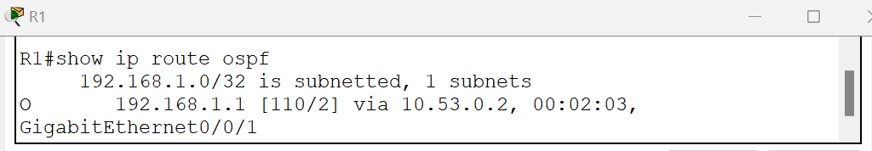

Fig. 36 – R1

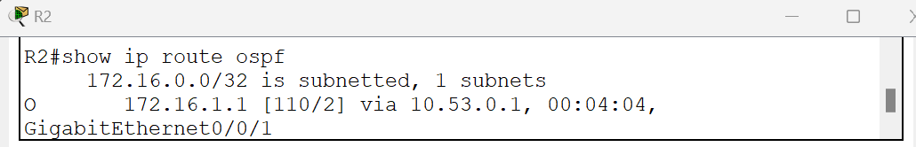

Fig. 37 – R2

1. Ping the R2 Loopback 1 interface address from R1 and vice versa. The ping should succeed.

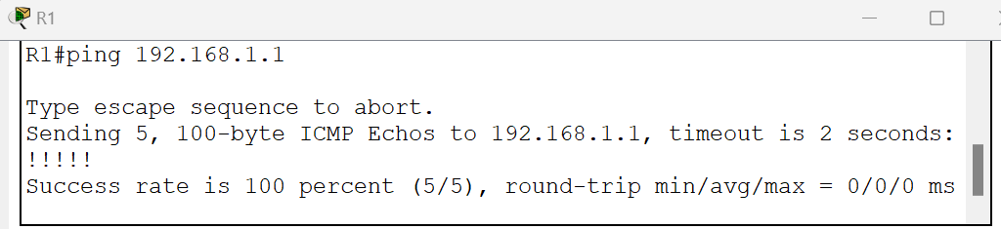

Fig. 38 – R1

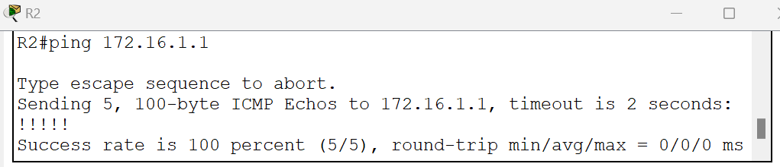

Fig. 39 – R2